**World Quant University**

**Professor: Ritabrata Bhattacharyya**

**Alpha Design II**

Nikolas Lippmann Pareschi - [nikolaslippmann@gmail.com](mailto:nikolaslippmann@gmail.com)

Introduction: Spyder PEP8 checker is truly a time saver, as I discovered reading the Piazza forum in Python 2. So, I have used it again for all classes and this Project I from Alpha Design II. I tried my best to avoid using modular code.

**Project: Risk-Adjusted Performance of Value Metrics**

* + - 1. Select a universe of 100 stocks spread across different industry verticals – information technology, utilities, banking and financial services, midcaps, large caps etc.

This is the list of stocks that we analyze in our project. I defined it outside of any function as global variable as I did with the fundamental metrics that will be used in other functions.

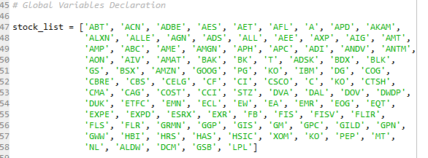



* + - 1. Download previous year’s balance sheets for all and calculate the following metrics:

Earnings Yield

EBITA

Free cash flow yield

Return on Capital Employed

Book to Market

I downloaded the data from finviz. I used P/E for Earning Yield, EPS for EBITA, P/FCF for Free Cash Flow Yield, ROI for Return on Capital Employed (Finviz did not have ROC) and P/B for Book to Market.

These were the functions used:

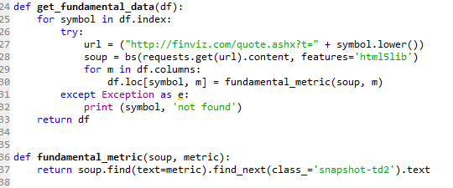

The source for these functions is: <https://www.quantinsti.com/blog/quantitative-value-investing-strategy-python/>

* + - 1. Arrange stocks in deciles in according to the value of these metrics:

the top decile being Glamour Stocks

bottom Decile being Value Stocks.

I arranged these stocks in the main function:

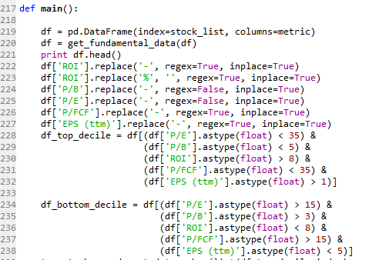

* + - 1. Choose only the Value decile stocks to proceed (you should roughly have 20 stocks in the value decile)

I understand that the project only asked to proceed with the Value decile, but I have done also for the growth decile for comparison purposes

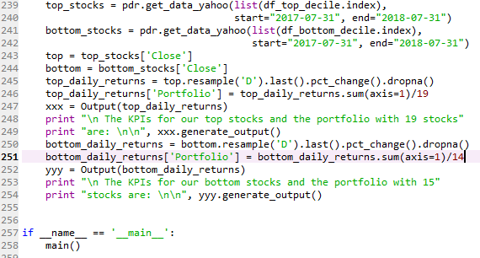

* + - 1. For the value decile stocks, calculate the following (from the time of publishing of last Annual report to date) risk  and return metrics

CAGR

Standard Deviation of Returns

Downside Deviation of Returns

Sharpe Ratio

Sortino Ratio (with MAR Set at 5%)

Worst Drawdown

Worst Moth Return

Best Month Return

Profitable Months

Excerpt from the Code for the KPIs:

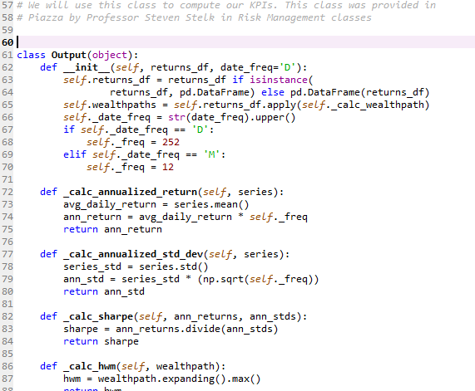

* + - * 1. Tabulate the results and identify which value metrics provide the best risk adjusted measure of return.

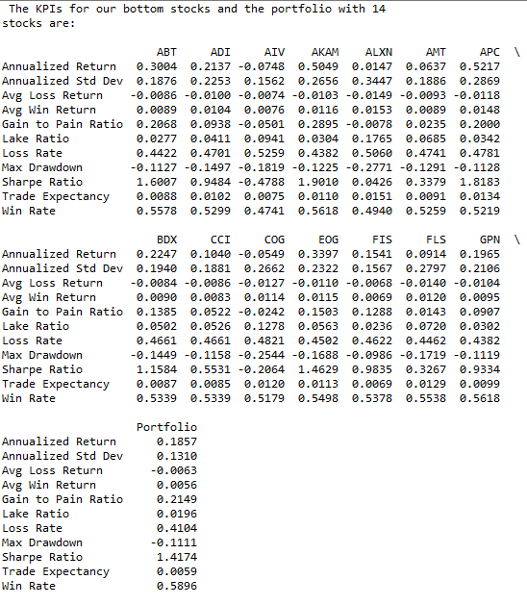



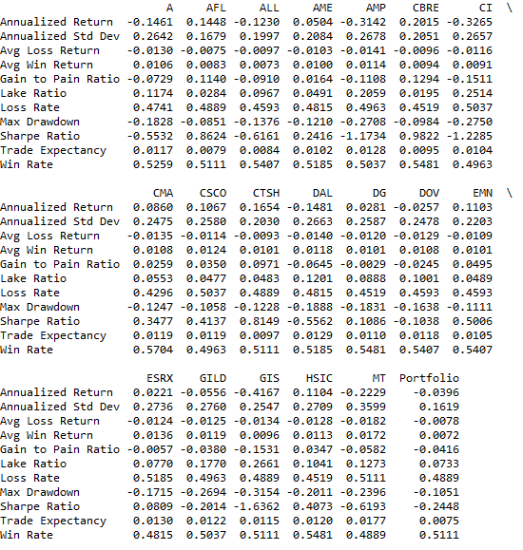

The results were very interesting because the glamour stock outperformed BY FAR the value stocks. But this is not a surprise considering the period of study. 2017 and 2018 are being years that glamour stocks like FANGs are dominating. The value investors are still waiting for the JEDI return.